CLICK ON TEACHER ACCESS

CLICK ON MY GRADEBOOK

CLICK ON GRADEBOOK

CLICK ON CATEGORIES
ALL GRADEBOOKS MUST BE SET UP AS WEIGHTED “Grades based on percent’s assigned to categories”
IF YOURS IS NOT-CLICK ON CHANGE SCORE METHOD. IF IT IS SKIP TO NEXT STEP.
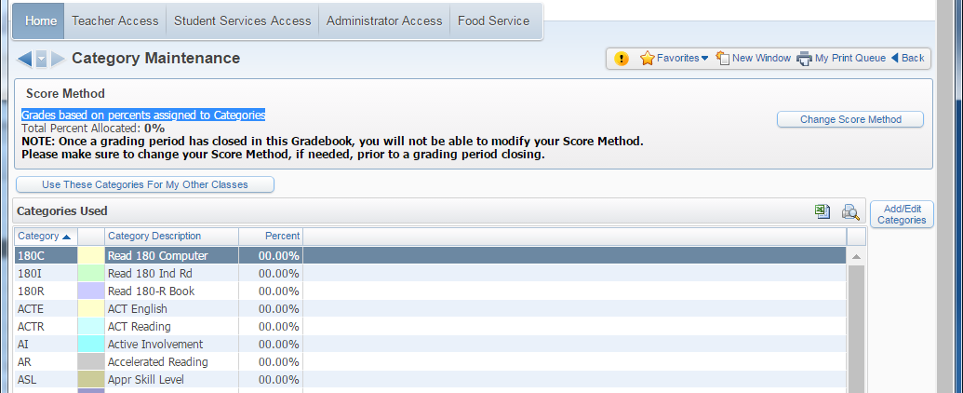

SELECT OPTION TWO AND SAVE
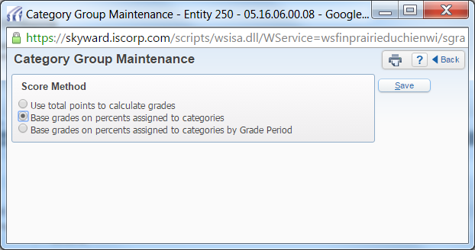
CLICK ON ADD/EDIT CATEGORIES
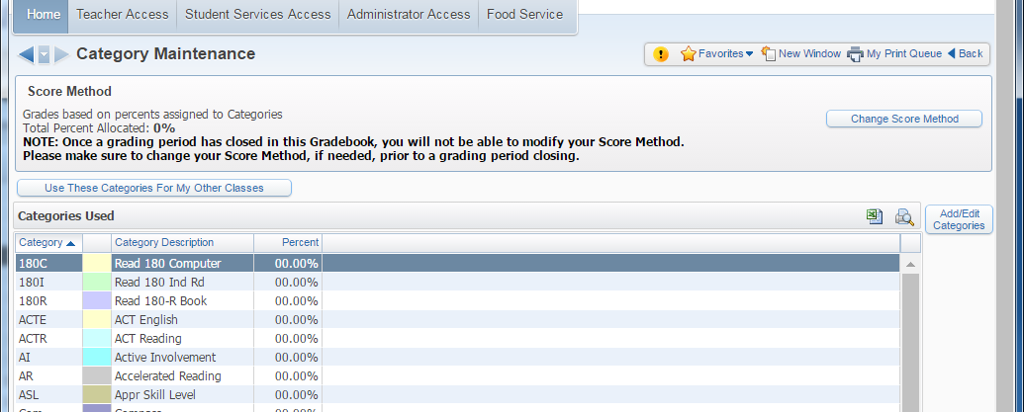

CLICK ON UNSELECT ALL

ALLOCATED PERCENT MUST EQUAL 100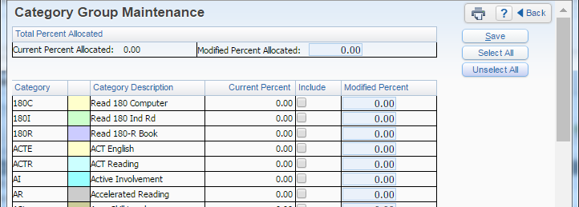
CHECK INCLUDE NEXT TO THE CATEGORY YOU WOULD LIKE TO USE AND ENTER THE MODIFED PERCENT. WHEN MODIFIED PERCENT EQUAL 100 CLICK SAVE.
